**Initial Velocity Prediction Based on Radial Basis Function (RBF) Neural Network**

Nan Hu, Weiqun Yuan, Rong Xu, Ducheng Zheng, Ping Yan, Ying Zhao and Wenping Cheng

*Institute of Electrical Engineering, Chinese Academy of Sciences*

*Address : No.6 North two Zhongguancun, Beijing, China*

*hunan@mail.iee.ac.cn*

**Abstract**

In this paper, an initial velocity prediction strategy in pulsed current driven system applying RBF neural network is proposed. Firstly, an RBF neural network model is built including an input layer, a hidden layer, and an output layer. Then it is trained with the preprocessed data set which includes four features armature mass, acceleration distance, current time integration and initial velocity of armature. By setting the target variables as initial velocity we trained a model predicting this variable. When the number of training samples reaches 400, the average prediction error on the test set reaches a minimum of 18.3 m/s(1.12%) and the prediction costs time 0.3 seconds, which shows the high accuracy and efficiency of this method. As it is based on a machine learning framework, which is easy to apply and flexible to expand, it has an undoubtable great advantage over the traditional numerical calculation with long calculation time and complicated structure.

**Keywords:** initial velocity prediction, Radial Basis Function, neural network, machine learning framework

1. Introduction

In pulsed current driven system, the pulse power supply network consists of a plurality of pulse power supply modules in parallel. The discharge timing of each module can be adjusted to change the current waveform which directly affects the initial velocity [1]. Therefore, precise speed control through current is the advantage of electromagnetic launch over the traditional emission method. It is absolutely meaningful to find a method to predict the initial velocity, as it is the basics of speed control. The initial velocity can be calculated by simulation of the launch process. Develop a transient electric circuit model for a pulsed current driven system and the transient performance of the system can be simulated through Micro-Cap VI, an electrical circuit analysis software package [2]. Also, researchers improved the calculation accuracy of the rails’ inductance and the force distribution upon the rails [3,4]. However, there are different degrees of simplification of working conditions and calculations in all above methods. It is often one-way coupling rather than two-way coupling that is used in these simulations. And the simulation time could be hours if more factors are considered.

In this paper, a new prediction strategy based on RBF neural network is presented. An RBF neural network is built, and then it is trained with the preprocessed data obtained in a simulation system. The accuracy of the simulation system has been verified experimentally [5]. The method is easy to apply and expand as it is based on the machine learning framework. Once the model has completed training, each initial velocity prediction can be completed in constant time, which has undoubted advantages considering about the complexity of numerical simulation.

2. RBF Neural Network Building and Training

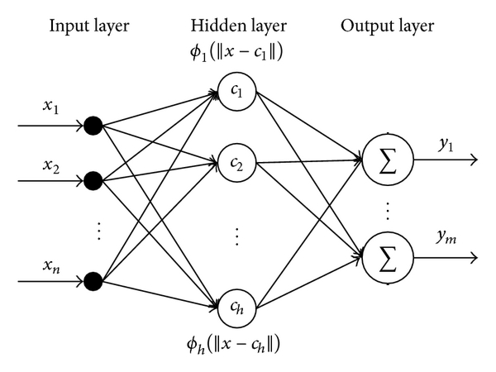

Fig. 1. The structure of the RBF neural network

The structure of the RBF neural network is shown in Fig.1. The first layer is the input layer. An input vector x is used as input to all radial basis functions. The second layer is the hidden layer with a non-linear RBF activation function, and the function is commonly taken to be Gaussian. The output of each RBF unit is as follows [6,7]:

 (1)

 is the input vector,  is the center of the ith RBF unit and can be determined by k means clustering algorithm [8].  indicates the Euclidean norm on the input space,  is the spread of ith RBF unit,  is the number of the neurons in the hidden layer. The output of the network is then a scalar function of the input vector.

 (2)

 indicates the pth sample,  indicates the jth neuron in the output layer,  is the output of the pth sample and the jth output neuron,  is the weight or strength of the ith neuron in hidden layer to the jth output ,  is the bias of the jth output. In order to reduce the network complexity, the bias is not considered in the following analysis.

We’ve got the data set including the mass of the armature , the acceleration distance ， the current time integration  and the initial velocity  through a simulation system, the accuracy of which has been verified experimentally [5]. Normalize each feature in the dataset as equation (3). For the ith feature,  is the converted data,  is the original data;  and  are the average and standard deviation of the feature data, respectively.

 (3)

We take  as input feature vector  and the initial velocity  as target variable. The input of RBF neural network is a 400*3 matrix and the output is a 400*1 matrix and a model predicting initial velocity is obtained.

3. Results

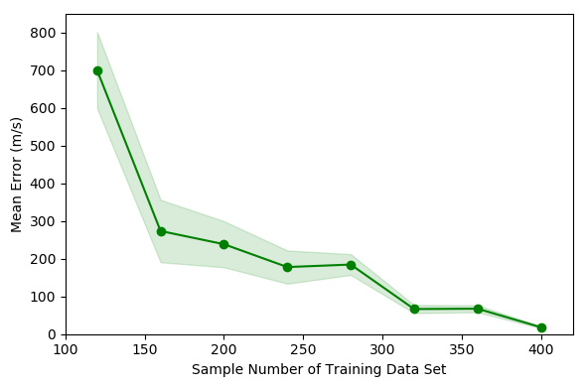

Fig.2. Error decreasing of with increasing number of training data

The relationship between prediction error on the test set and the number of training samples is shown in Fig. 2. The test set contains 20 samples which are not included in the training data. In this study, the average error is the average of the absolute value of the error, so it is a positive number. The shaded part reflects the standard deviation of the prediction error. When the training sample is small, the standard deviation is extremely large, and 0.1 times the actual standard deviation is used for the convenience of displaying the map.

Fig.2 shows that when the number of training samples reaches 400, the average prediction error on the test set reaches a minimum of 18.3 m/s, the mean absolute percentage error is 1.12% and the standard deviation is 25.76 m/s. Therefore, the model trained with 400 samples is the optimal prediction model which has 160 hidden layer neurons and the spread of radial basis functions is 0.93. Training model takes 3.6 seconds and the prediction of the 20 samples of the test set takes 0.3 seconds.

The testing result indicates that applying the RBF neural network for the prediction of the initial velocity in pulsed current driven system is very accurate and efficient.

4. References

[1] H. D. Fair. Electric launch science and technology in the United States[J]. IEEE Transactions on Magnetics, 2003, 39(1): 11–17.

[2] J. S. Bernardes, M. F. Stumborg, and T. E. Jean. Analysis of a capacitor-based pulsed-power system for driving long-range electromagnetic guns[J]. IEEE Transactions on Magnetics, 2003, 39(1): 486–490.

[3] BAYATI M S, KESHTKAR A, KHOSRAVI F et al. Analyzing the electromagnetic launcher with combination both FEM-3D and IEM methods in time domain[C]//2012 16th International Symposium on Electromagnetic Launch Technology. 2012: 1–7.

[4] GHASSEMI M, BARSI Y M, HAMEDI M H. Analysis of Force Distribution Acting Upon the Rails and the Armature and Prediction of Velocity With Time in an Electromagnetic Launcher With New Method[J]. IEEE Transactions on Magnetics, 2007, 43(1): 132–136.

[5] Yuan Ruimin．Study on Trigger Strategy of Pulse High Current Timing Discharge [D]. Institute of Electrical Engineering, Chinese Academy of Sciences. 2017.

[6] WANG Z, YANG B, KANG Y et al. Development of a Prediction Model Based on RBF Neural Network for Sheet Metal Fixture Locating Layout Design and Optimization[J]. Computational Intelligence and Neuroscience, 2016, 2016: 1–6.

[7] ER M J, WU S, LU J et al. Face recognition with radial basis function (RBF) neural networks[J]. IEEE Transactions on Neural Networks, 2002, 13(3): 697–710.

[8] LIKAS A, VLASSIS N, J. VERBEEK J. The global k-means clustering algorithm[J]. Biometrics, 2003, 36(2): 451–461.